Custom Command Styles With Laravel Artisan
Laravel
·11 min read ·  John Koster
Since Laravel's console application and commands are built on top of the Symfony console component, we can use Symfony's console style system within our Laravel commands. Styles are used to control the background and foreground colors of text that is displayed in the console window. Other options exist to further change the appearance of text (such as bold or underscore).
There are two ways to define styles. One is to define styles in-line using a special syntax enclosed in angle brackets similar to HTML. The following example would write a line to the console window with red text. It is important to note that when defining styles in-line that the style tags need to be closed with the </> closing tag.
<?php

// ...

function handle()
{
$this->line('<fg=red>A simple line.</>');
}

// ...
To set the foreground color when styling command text set the fg property to a valid foreground color value. The background color can also be styled by setting the bg property to a valid background color value. The following example would also set the background color to yellow. Note that each property is separated by a semicolon.
<?php

// ...

$this->line('<fg=red;bg=yellow>A simple line.</>');

// ...
It is also possible to only style certain sections of the message (line breaks have been added to improve readability of the code sample):
<?php

// ...

$this->line('<fg=black>Black <fg=red>Red <fg=green>Green <fg=yellow>Yellow
<fg=blue>Blue <fg=magenta>Magenta <fg=cyan>Cyan
<fg=white;bg=black>White <fg=default;bg=black>Default</>');

// ...
It should also be noted that only one </> closing tag was added to the previous code sample. This is a feature that makes it simpler to add many styles in one message without having to clutter it with numerous closing tags. The previous example might generate a line similar to the following image:
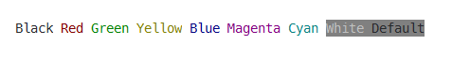
The following table lists the valid foreground and background colors:
Color | Value | Example
Black | black | fg=black;bg=black
Red | red | fg=red;bg=red
Green | green | fg=green;bg=green
Yellow | yellow | fg=yellow;bg=yellow
Blue | blue | fg=blue;bg=blue
Magenta | magenta | fg=magenta;bg=magenta
Cyan | cyan | fg=cyan;bg=cyan
White | white | fg=white;bg=white
Default | default | fg=default;bg=default
Options can also be used to change various aspects of the text as it is displayed. The following table lists each of the various options and a description of each:
Option | Value | Description
Bold | bold | Causes the formatted text to display more brightly than the surrounding text.
Underscore | underscore | Underlines the styled text.
Blink | blink | Causes the styled text to blink within the console terminal. Note: most modern terminals do not support blink.
Reverse | reverse | Swaps the foreground and background colors for the styled text.
Conceal | conceal | Sets the foreground color to transparent. This effectively makes the typed text invisible.
Styles can also be created by creating an instance of Symfony\Component\Console\Formatter\OutputFormatterStyle class. The signature for the OutputFormatterStyle constructor is:
<?php

// ...

/**
* Initializes output formatter style.
*
* @param string|null $foreground The style foreground color name
* @param string|null $background The style background color name
* @param array $options The style options
*/
public function __construct(
$foreground = null,
$background = null,
array $options = array()
){}
The OutputFormatterStyle class can accept the foreground and background colors as well as an array of options. Each parameter is optional and not setting any values will cause the style to use the default values. When styles are created using the OutputFormatterStyle class they generally need to be registered with the console applications output formatter. The following example creates a new style, registers it and then uses it to produce some output.
<?php

// ...

use Symfony\Component\Console\Formatter\OutputFormatterStyle;

// ...

function handle()
{
$style = new OutputFormatterStyle('white', 'blue', ['bold']);
$this->output->getFormatter()->setStyle('bigBlue', $style);

// Notice that we use the name of our new style inside the tags.
$this->line('<bigBlue>Hello, there</bigBlue>');
}

// ...

#Table Styles
The way tabular data is rendered in your commands can be customized extensively. Customizing the way table cells, dividers and headers are rendered is not as simple as passing an array of data to a method, but it is not incredibly difficult. To create customized tables you will need to work with the following classes from the Symfony console component:
- Symfony\Component\Console\Helper\Table
- Symfony\Component\Console\Helper\TableSeparator
- Symfony\Component\Console\Helper\TableCell
The Table class is the starting point to creating any table (Laravel's table method internally creates an instance of Table). When creating a new instance of the Table class we must supply an instance of Symfony\Component\Console\Output\OutputInterface to the constructor as the only argument. Luckily there is an instance of that interface stored in each commands $output property. Creating a new Table instance within a Laravel command might look like this:
<?php

// ...

use Symfony\Component\Console\Helper\Table;

// ...

function handle()
{
// Create a new Table instance.
$table = new Table($this->output);

// Set the table headers.
$table->setHeaders([
'Site', 'Description'
]);

// Set the contents of the table.
$table->setRows([
['https://laravel.com', 'The official Laravel website'],
['https://forge.laravel.com/', 'Painless PHP Servers'],
['https://envoyer.io/', 'Zero Downtime PHP Deployment']
]);

// Render the table to the output.
$table->render();

}

// ...
After a command similar to the previous example has executed the user might see something similar in their console window:
+----------------------------+------------------------------+
| Site | Description |
+----------------------------+------------------------------+
| https://laravel.com | The official Laravel website |
| https://forge.laravel.com/ | Painless PHP Servers |
| https://envoyer.io/ | Zero Downtime PHP Deployment |
+----------------------------+------------------------------+
So far the table looks similar to the output generated by Laravel's table method. However, since we are working directly with the Table class we can use Symfony features to customize how the table is generated and rendered. The following example adds a separator between each of the table rows:
<?php

// ...

use Symfony\Component\Console\Helper\Table;
use Symfony\Component\Console\Helper\TableSeparator;

// ...

function handle()
{
// Create a new Table instance.
$table = new Table($this->output);

// Set the table headers.
$table->setHeaders([
'Site', 'Description'
]);

// Create a new TableSeparator instance.
$separator = new TableSeparator;

// Set the contents of the table.
$table->setRows([
['https://laravel.com', 'The official Laravel website'],
$separator,
['https://forge.laravel.com/', 'Painless PHP Servers'],
$separator,
['https://envoyer.io/', 'Zero Downtime PHP Deployment']
]);

// Render the table to the output.
$table->render();

}

// ...
After the previous example has executed the user might see something similar to the following output (notice the new separators between the table rows):
+----------------------------+------------------------------+
| Site | Description |
+----------------------------+------------------------------+
| https://laravel.com | The official Laravel website |
+----------------------------+------------------------------+
| https://forge.laravel.com/ | Painless PHP Servers |
+----------------------------+------------------------------+
| https://envoyer.io/ | Zero Downtime PHP Deployment |
+----------------------------+------------------------------+
Managing TableSeparator Instances
In the previous example we created an instance of TableSeparator before adding the table data. Most examples demonstrate the table separator feature by creating a new instance of TableSeparator each time one is needed. On smaller datasets, this is not an issue, but on extremely large datasets this could cause issues in low memory environments. Each method is fine, but be aware of the intended data set size and memory considerations of the running environment.
Table cells can also be set to span multiple columns and rows, much like in HTML. To do this, table cells must be created explicitly by creating an instance of the TableCell class. The following example combines the previous example and column spanning to create a more interesting table:
<?php

// ...

use Symfony\Component\Console\Helper\Table;

// ...

function handle()
{
// Create a new Table instance.
$table = new Table($this->output);

// Set the table headers.
$table->setHeaders([
'Site', 'Description'
]);

// Create a new TableSeparator instance.
$separator = new TableSeparator;

// Set the contents of the table.
$table->setRows([

// Create a row with only one table cell.
[new TableCell('First Party', ['colspan' => 2])],
$separator,

['https://laravel.com', 'The official Laravel website'],
['https://forge.laravel.com/', 'Painless PHP Servers'],
['https://envoyer.io/', 'Zero Downtime PHP Deployment'],

$separator,

// Create a row with only one table cell.
[new TableCell('Useful Resources', ['colspan' => 2])],
$separator,

['https://laracasts.com/', 'The Best Laravel and PHP Screencasts'],
['https://laracasts.com/discuss', 'Laracasts Web Development Forum']
]);

// Render the table to the output.
$table->render();

}

// ...
After the previous command has executed the user would see a table similar to the following output:
+-------------------------------+--------------------------------------+
| Site | Description |
+-------------------------------+--------------------------------------+
| First Party |
+-------------------------------+--------------------------------------+
| https://laravel.com | The official Laravel website |
| https://forge.laravel.com/ | Painless PHP Servers |
| https://envoyer.io/ | Zero Downtime PHP Deployment |
+-------------------------------+--------------------------------------+
| Useful Resources |
+-------------------------------+--------------------------------------+
| https://laracasts.com/ | The Best Laravel and PHP Screencasts |
| https://laracasts.com/discuss | Laracasts Web Development Forum |
+-------------------------------+--------------------------------------+
Having table cells span multiple rows is very similar to setting cells to span multiple columns. Instead of setting the colspan option, simply set the rowspan option on the table cell. The colspan and rowspan options can be combined to have cells span multiple rows and columns to create more complicated table layouts.
Text styles can also be used when rendering tables (such as info and error) to further customize how tables are rendered. The following example will build on all of the previous examples to add a new "Status" column to our sites table. This column could be used to display the status of the website or status.
<?php

// ...

use Symfony\Component\Console\Helper\Table;

// ...

function handle()
{
// Create a new Table instance.
$table = new Table($this->output);

// Set the table headers.
$table->setHeaders([
'Site', 'Description', 'Status'
]);

// Create a new TableSeparator instance.
$separator = new TableSeparator;

// Set the contents of the table.
$table->setRows([
[new TableCell('First Party', ['colspan' => 3])],
$separator,
[
'https://laravel.com',
'The official Laravel website',
'<info>Online</info>'
],
[
'https://forge.laravel.com/',
'Painless PHP Servers',
'<info>Online</info>'
],
[
'https://envoyer.io/',
'Zero Downtime PHP Deployment',
'<info>Online</info>'
],
$separator,
[new TableCell('Useful Resources', ['colspan' => 3])],
$separator,
[
'https://laracasts.com/',
'The Best Laravel and PHP Screencasts',
'<info>Online</info>'
],
[
'https://laracasts.com/discuss',
'Laracasts Web Development Forum',
'<info>Online</info>'
],
$separator,
[new TableCell('Other', ['colspan' => 3])],
$separator,
[
'example.org',
'An example experiencing issues.',
'<bg=yellow;fg=black>Experiencing Issues</>']
,
['example.org', 'An example offline site.', '<error>Offline</error>']
]);

// Render the table to the output.
$table->render();

}

// ...
The previous example would generate a table similar to the following figure. Notice that the values in the Status column have been styled to provide additional information to the end user.
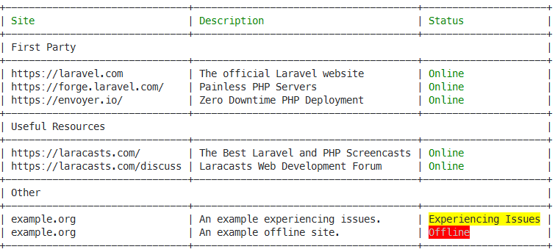
∎
Thanks for taking the time to read this post! If you found this article useful and want to help support more work like this, please consider sponsoring my work on GitHub, or by checking out some merch.
https://stillat.com/blog/2016/12/03/custom-command-styles-with-laravel-artisan

Fun at the Laravel Console
February 10, 2020

When I spun up a new Livewire component with artisan (Laravel's CLI tool) recently, I was intrigued enough by the cute ASCII logo to take a look at the source code to see how it was made.
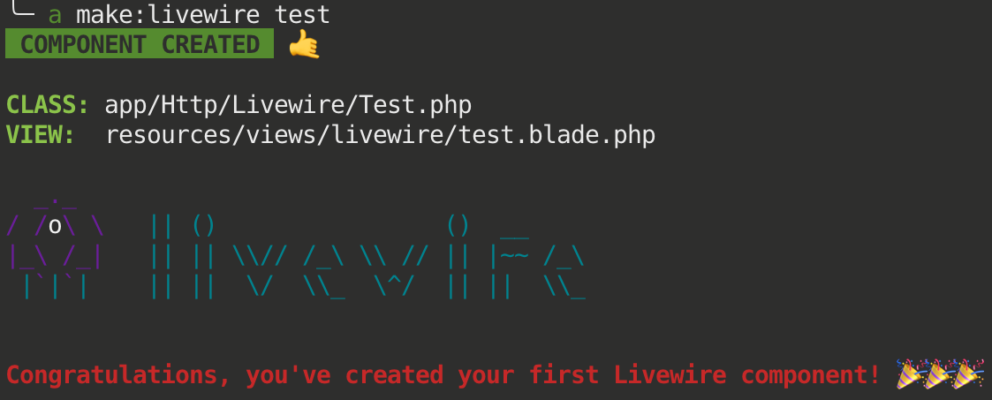
What interested me the most was not the logo itself, but rather the custom colors. I admit I haven't dug deep before into what makes these console commands tick. To my knowledge, Laravel doesn't offer custom colors out of the box.

Enter Symfony's Console Formatter
I already knew that Laravel's console uses Symfony's Console Output Formatter package(s) under the hood, which in turn offer a variety of colors and styles that you can apply to your output.

It's all downhill from here
Armed with this knowledge, the <fg=cyan>...</> tags in Livewire's code made perfect sense now.
For my future convenience I created the following two commands:

1. List all the default Symfony styles
Command gist

2. Generate a Ghostbusters logo
The Ghostbusters logo was copied from this lovely repository of ASCII art. The Laravel console command in the gist generates the colored logo in the main article image.
Command gist

Reference
Let's take a closer look at what colors and styles are available and how they can be applied.
Foreground colors
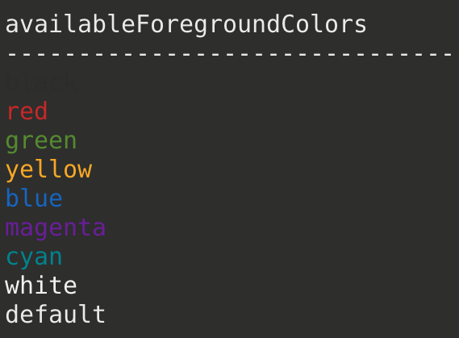
Usage:
$this->line('<fg=magenta>Magenta text</>');
Background colors
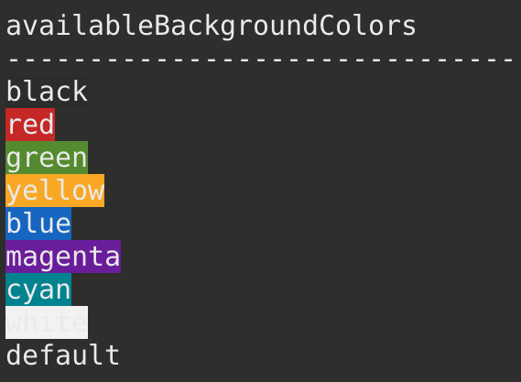
Usage:
$this->line('<bg=blue>Blue background</>');
Options
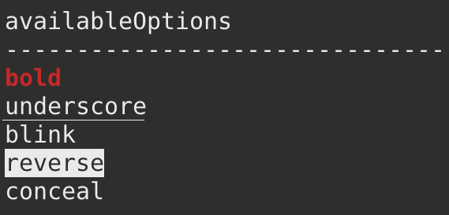
Usage:
$this->line('<options=bold>Bold text</>');
Styles
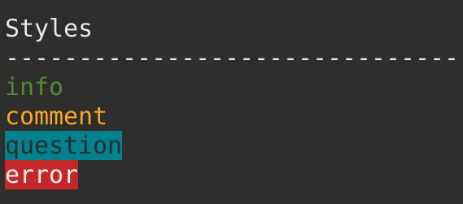
Usage (each style is its own individual tag):
$this->line('<question>question</question>');
Custom combos
You may certainly combine the above to produce custom effects.
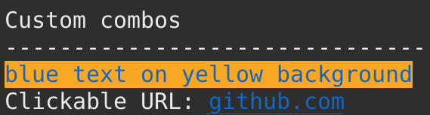
Usage:
$this->line('<fg=blue;options=blink;bg=yellow>blue text on yellow background</>');
$this->line('Clickable URL: <href=https://github.com;fg=blue;options=underscore>github.com</>');
I don't know about you but I'll be sure to make my future Laravel console command output more colorful!
https://chasingcode.dev/blog/laravel-console-fun/

How to Color and Style the Console Output
Edit this page
- Using Color Styles
  - Displaying Clickable Links
By using colors in the command output, you can distinguish different types of output (e.g. important messages, titles, comments, etc.).
By default, the Windows command console doesn't support output coloring. The Console component disables output coloring for Windows systems, but if your commands invoke other scripts which emit color sequences, they will be wrongly displayed as raw escape characters. Install the Cmder, ConEmu, ANSICON, Mintty (used by default in GitBash and Cygwin) or Hyper free applications to add coloring support to your Windows command console.

Using Color Styles
Whenever you output text, you can surround the text with tags to color its output. For example:
// green text
$output->writeln('<info>foo</info>');

// yellow text
$output->writeln('<comment>foo</comment>');

// black text on a cyan background
$output->writeln('<question>foo</question>');

// white text on a red background
$output->writeln('<error>foo</error>');
The closing tag can be replaced by </>, which revokes all formatting options established by the last opened tag.
It is possible to define your own styles using the OutputFormatterStyle class:
use Symfony\Component\Console\Formatter\OutputFormatterStyle;

// ...
$outputStyle = new OutputFormatterStyle('red', '#ff0', ['bold', 'blink']);
$output->getFormatter()->setStyle('fire', $outputStyle);

$output->writeln('<fire>foo</>');
Any hex color is supported for foreground and background colors. Besides that, these named colors are supported: black, red, green, yellow, blue, magenta, cyan, white, gray, bright-red, bright-green, bright-yellow, bright-blue, bright-magenta, bright-cyan and bright-white.
If the terminal doesn't support true colors, the nearest named color is used. E.g. #c0392b is degraded to red or #f1c40f is degraded to yellow.
And available options are: bold, underscore, blink, reverse (enables the "reverse video" mode where the background and foreground colors are swapped) and conceal (sets the foreground color to transparent, making the typed text invisible - although it can be selected and copied; this option is commonly used when asking the user to type sensitive information).
You can also set these colors and options directly inside the tag name:
// using named colors
$output->writeln('<fg=green>foo</>');

// using hexadecimal colors
$output->writeln('<fg=#c0392b>foo</>');

// black text on a cyan background
$output->writeln('<fg=black;bg=cyan>foo</>');

// bold text on a yellow background
$output->writeln('<bg=yellow;options=bold>foo</>');

// bold text with underscore
$output->writeln('<options=bold,underscore>foo</>');
If you need to render a tag literally, escape it with a backslash: \<info> or use the escape() method to escape all the tags included in the given string.

Displaying Clickable Links
Commands can use the special <href> tag to display links similar to the <a> elements of web pages:
$output->writeln('<href=https://symfony.com>Symfony Homepage</>');
If your terminal belongs to the list of terminal emulators that support links you can click on the "Symfony Homepage" text to open its URL in your default browser. Otherwise, you'll see "Symfony Homepage" as regular text and the URL will be lost.
This work, including the code samples, is licensed under a Creative Commons BY-SA 3.0 license.
https://symfony.com/doc/current/console/coloring.html

